Our online system is accessible to everyone, with no need to download an app or log in. All you need is access to the internet and you can access the system from any device, including your smartphone or tablet. Simply visit:
https://www.wadhurstmedicalgroup.co.uk/.

An appointment request can then be submitted by:

- Clicking on the Appointments tab at the top of our Homepage



- Selecting the ‘Urgent appointments’ or ‘Routine appointments’ link

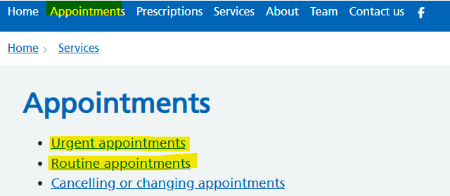

- Selecting ‘Health review’

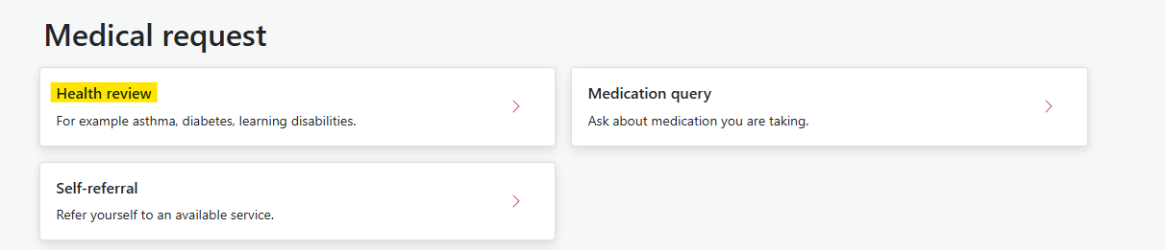

- Selecting ‘Health problem’

